2.0 **Types and Consensus 2**

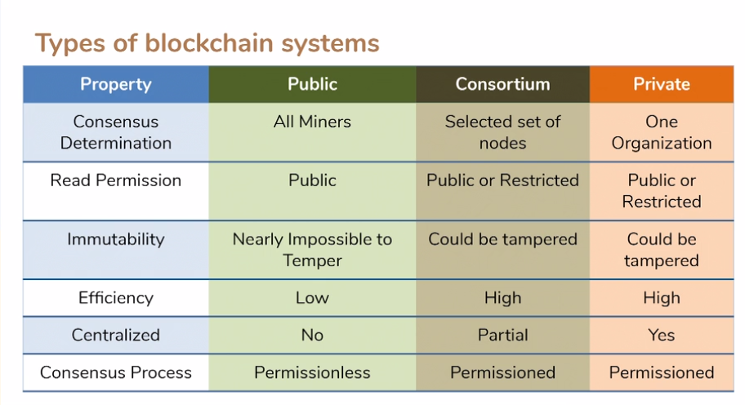

**Bitcoin perform 7 transaction per second while Ethereum perform 15**